Advanced System on Chip Design Course
Getting Started Guide
Issue 1.0

Contents
1 Introduction 1
1.1 Learning Outcomes 1
1.2 Scope of this guide 1
2 Requirements 2
2.1 Software requirements 2
2.2 Hardware requirements 2
3 Xilinx software setup 3
3.1 Vivado 3
3.1.1 Starting a new project 3
3.2 Vitis IDE 4
3.2.1 Creating an application project 4
3.3 Arm Development Studio 6
3.3.1 Importing existing DS-5 projects 6
4 Troubleshooting 7
4.1 Issues when using Vivado 7
4.1.1 Facing NSTD-1 and UCIO-1 errors when generating bitstream 7
4.1.2 Critical warnings: PCW_UIPARAM_DDR_DQS_TO_CLK_DELAY_x has negative value 7
4.2 Issues when using Vitis IDE 7
4.2.1 Makefile errors 7

Introduction

Learning Outcomes
At the end of this lab, you will be able to:
- Identify the hardware and software requirements for the lab exercises
- Demonstrate how to create a project in Xilinx Vivado and Vitis tools.
- Use Arm Development Studio to import lab projects.
- Identify known issues and apply troubleshooting solutions.

Scope of this guide
This Getting Started Guide is intended to give you the necessary information to install and configure the tools for the labs of this course.
NOTE: This guide assumes that:
- You are working with a Windows OS

Requirements
This section describes the software and hardware requirements in order to attempt all the labs within this course.
Software | Website | Version¹ | OS
Xilinx Vivado ML | https://www.xilinx.com/support/download.html | 2020.1 | Windows
Xilinx Vitis IDE | https://www.xilinx.com/support/download/index.html/content/xilinx/en/downloadNav/vitis.html | 2021.1 | Windows
Arm Development Studio | https://developer.arm.com/tools-and-software/embedded/arm-development-studio/evaluate | Platinum 2021.b | Windows

Software requirements
Table 1: Software tools and versions
¹ The software versions listed here are versions that we have verified to be working with our labs. You can use the latest available (and most stable) versions of the software, if backward and forward compatibility is supported.

Hardware requirements
- Diligent Zybo Z7-10 FPGA board
- Monitor with HDMI support
- 2 HDMI cables
- USB A to micro USB Cable

Xilinx software setup

Vivado
To create a new project, first choose a workspace such that the path does not contain any spaces. For Windows OS, this could be a folder in the main working directory like “C:/Workspace”.

Starting a new project
Open Vivado, click “Create Project” and choose the location as the workspace:
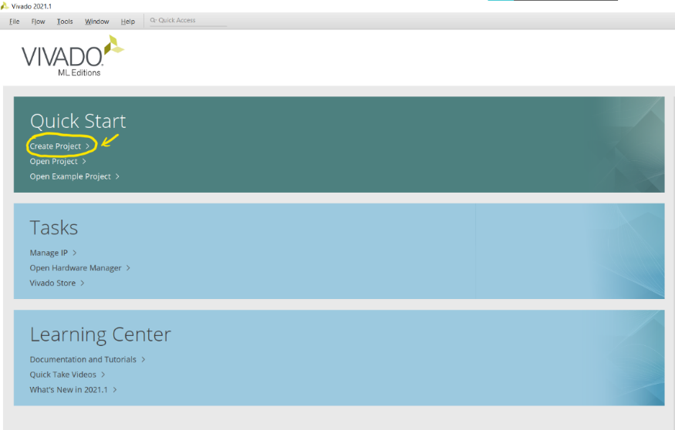
Figure 1: Vivado start page

Give it a meaningful name and click next. Select RTL Project and click “Next”:
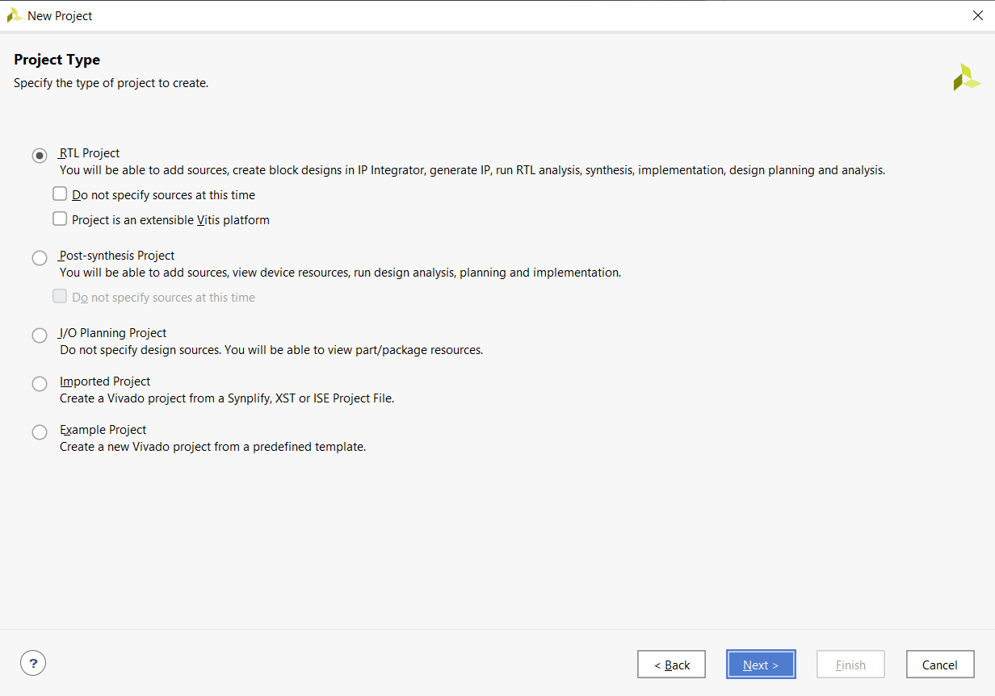
Figure 2: Vivado project type
Skip through the next two pages as the constraints file can be added at a later stage. In the next page first search for “Zybo” in the search bar and click the download button next to “Zybo Z7-10” if the option is available. Then select it and click “Next” (Do not click the hyperlink but click the empty area next to “Zybo Z7-10”). Finally click “Finish”.
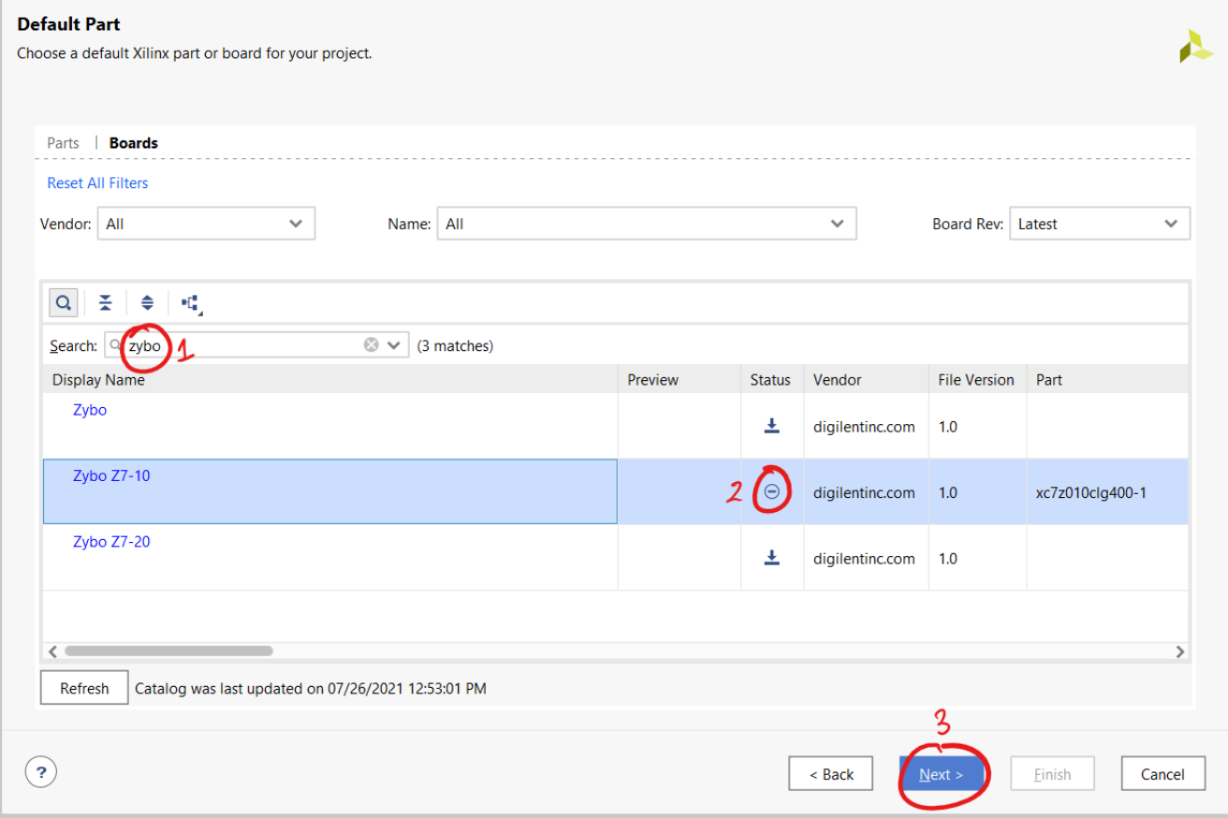
Figure 3: Choosing a board

A new project has been created and block designs can now be added. Once done with the block diagram, add the constraints file and generate the bitstream. Then, click “File” and “export hardware”. Select the option to include the bitstream and save the XSA file in the project folder.

Vitis IDE
To open the Vitis IDE from Vivado, click “Tools” in the menu bar and select “Launch Vitis IDE”. Choose the same project folder as your workspace.

Creating an application project
Click “File” -> “New” -> “Application Project”.
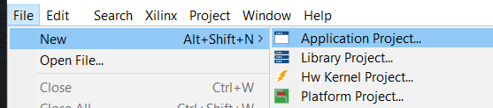
Figure 4: Creating an application project

Select the following tab and click browse to select the XSA file saved earlier:
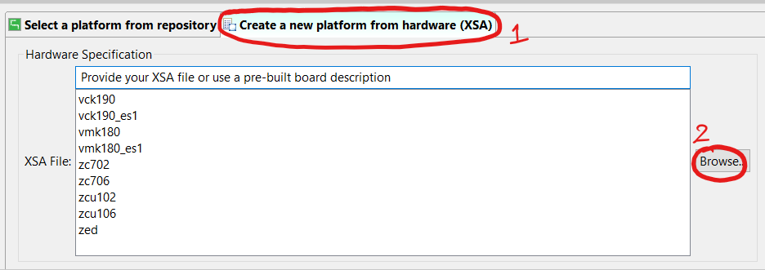
Figure 5: Choosing the XSA file

Click next and give a name to the application project. Click “Next” until you reach the following page and choose “Empty Application(C)” and click “Finish”:
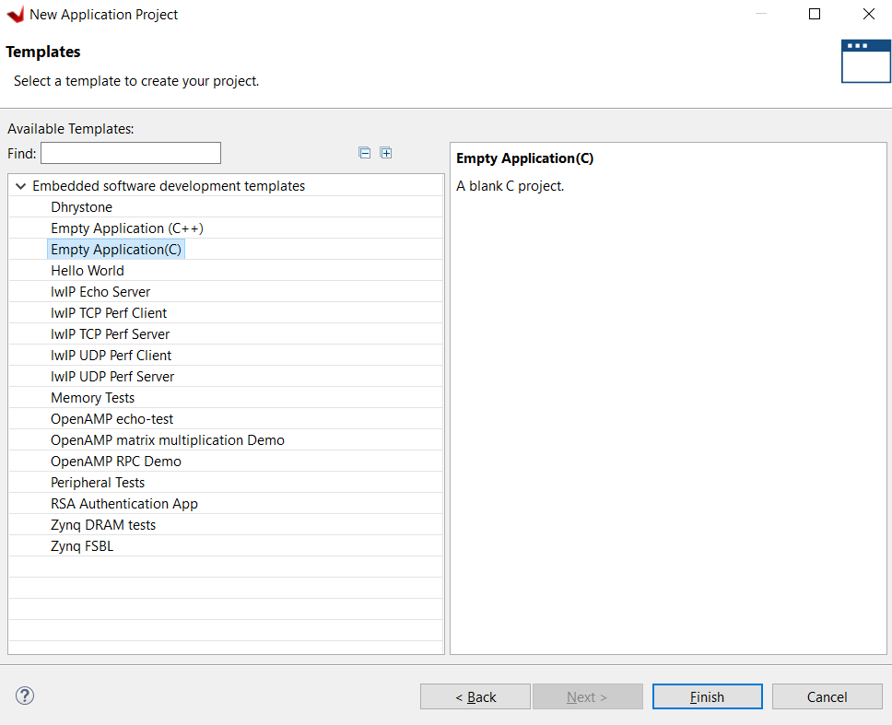
Figure 6: Creating an empty application

Once this is done, C code can be written within a file and added to the “src” folder within the application project.

Arm Development Studio
The Arm DS-5 IDE has been superseded by Arm Development Studio. Some of the labs were developed using the Arm DS-5, these should also work in the latest Arm Development Studio.

Importing existing DS-5 projects
Existing DS-5 projects can be imported into Arm Development Studio.
When importing existing DS-5 projects into Arm Development Studio, you might get prompted to migrate the existing projects to the new Arm Development Studio for future compatibility. Select OK. For example, see the snapshot below:
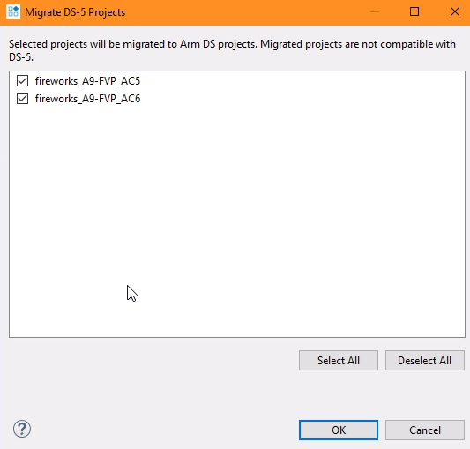

Troubleshooting
This section provides some guidance on resolving known issues when using Vivado and Vitis

Issues when using Vivado

Facing NSTD-1 and UCIO-1 errors when generating bitstream
Follow the solution given at: https://www.xilinx.com/support/answers/56354.html.

Critical warnings: PCW_UIPARAM_DDR_DQS_TO_CLK_DELAY_x has negative value
Read the hardware errata document: https://digilent.com/reference/programmable-logic/zybo-z7/reference-manual?redirect=1#hardware_errata

Issues when using Vitis IDE

Makefile errors
Replace all the code in 3 makefiles located in the following places in the explorer tab:
- hw/drivers/<IP NAME>/src/Makefile
- ps7_cortexa9_0/standalone_ ps7_cortexa9_0/bsp/ ps7_cortexa9_0/libsrc/<IP NAME>/src/Makefile
- zynq_fsbl/zynq_fsbl_bsp/ps7_cortexa9_0/libsrc/<IP NAME>/src/Makefile
 | <IP NAME> can vary depending on what procedure is followed in the lab. For example, in Lab 7, if the downloaded AXI4 peripheral files are used then <IP NAME> will be “axi_gpio_asoc_v1_0”.
Replace all the code with the following:
COMPILER=
ARCHIVER=
CP=cp
COMPILER_FLAGS=
EXTRA_COMPILER_FLAGS=
LIB=libxil.a
RELEASEDIR=../../../lib
INCLUDEDIR=../../../include
INCLUDES=-I./. -I${INCLUDEDIR}
INCLUDEFILES=*.h
LIBSOURCES= $(wildcard *.c)
OUTS = *.o
OBJECTS = $(addsuffix .o, $(basename $(wildcard *.c)))
ASSEMBLY_OBJECTS = $(addsuffix .o, $(basename $(wildcard *.S)))
libs:
echo "Compiling axi_gpio_asoc..."
$(COMPILER) $(COMPILER_FLAGS) $(EXTRA_COMPILER_FLAGS) $(INCLUDES) $(LIBSOURCES)
$(ARCHIVER) -r ${RELEASEDIR}/${LIB} ${OBJECTS} ${ASSEMBLY_OBJECTS}
make clean
include:
${CP} $(INCLUDEFILES) $(INCLUDEDIR)
clean:
rm -rf ${OBJECTS} ${ASSEMBLY_OBJECTS}

