Random signals and SYSTEm identification

# Overview

This exercise concerns random signals, their properties, and what happens to them when they pass through linear time-invariant systems. System identification based on correlation is compared with system identification using linear adaptive filters. You will use MATLAB to process and analyse data saved from the FM4 board.

## Hardware

To carry out this exercise you will need a Cypress FM4 board, an oscilloscope, an audio frequency signal generator, a PC running *Keil MDK-ARM* and M*ATLAB*, and suitable connecting cables. If available, the program *GoldWave* is a useful alternative to the FFT function on an oscilloscope.

Figure 1. Cypress FM4 board connections.

The methods of analysis you will use, and MATLAB code to compute time-averaged estimates of autocorrelation (ACF) and cross correlation (CCF) functions are described in the lecture slides.

The signal data that you will analyse using MATLAB will be generated using the FM4 board. Data from the FM4 board saved in Intel hex format in .dat files may be converted for MATLAB and stored in .mat files using MATLAB function fm4_convert_data.m. Data in MATLAB .mat files can be loaded into the workspace using the load command.

The program you will run on the FM4 board is named fm4_sysid_CMSIS_correlate_intr.c. This is represented as a block diagram in Figure 2. As provided, the program features a five-point moving average filter. But any FIR filter can be substituted for the moving average filter simply by changing the line that reads #include “ave5.h”.

FM4 Starter Kit

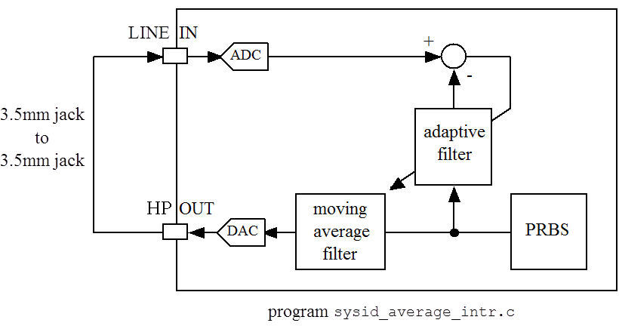

Figure 2. Connection diagram for identification of magnitude frequency response of five point moving average filter using program fm4_sysid_CMSIS_correlate_intr.c.

Run the program for a few seconds before halting it and saving the following data into separate .dat files.

firCoeffs32, 256 floating point adaptive filter coefficients (0x400 bytes) representing the impulse response of the signal path from the input of the moving average filter (FIR) to the output of the ADC.

saved_input, 8192 floating point samples (0x8000 bytes) of the pseudo-random noise signal input to the FIR filter.

saved_output, 8192 floating point samples (0x8000 bytes) of the signal output by the ADC.

saved_filtered, 8192 floating point samples (0x8000 bytes) of the signal output by the FIR filter and input to the DAC.

Use MATLAB function fm4_logfft() to display the magnitude frequency response corresponding to the impulse response contained in the coefficients firCoeffs32 of the adaptive filter. MATLAB function fm4_logfft() reads data from an Intel hex format .dat file as opposed to a MATLAB .mat file.

# Estimation of POWER RESPONSE of Signal Path

This laboratory exercise has explored several different methods of estimating the power response of a signal path, Use MATLAB (write MATLAB scripts) to estimate and graph (decibel magnitude scale, linear frequency scale) **estimates of the power response** (magnitude frequency response squared ${\left|H(\hat{ω})\right|}^{2}$) of the signal path from the input to the FIR filter to the output of the ADC in Figure 2 obtained four different ways.

1. Using an **adaptive filter ${\left|\hat{H}\left(k\right)\right|}^{2}={\left|\text{DFT}\left\{\hat{h}(n)\right\}\right|}^{2}$** where $\hat{h}(n)$ are the adaptive filter coefficients.
2. **Indirect estimation (correlogram) ${\left|\hat{H}\left(k\right)\right|}^{2}=\frac{\left|{\hat{S}}_{yy}(k)\right|}{σ_{x}^{2}}=\frac{1}{σ_{x}^{2}}\left|\text{DFT}\left\{w(m){\hat{∅}}_{yy}(m)\right\}\right|$**  where ${\hat{∅}}_{yy}(m)$, $-M≤m≤M$ is a length $(2M+1)$ estimate of the ACF of $y(n)$ the output from the ADC, and $w(m)$ is a Bartlett window function. The DFT has $(2M+1)$ points. Use the example code from the lecture slides to estimate the ACF.
3. **Direct Estimation (periodogram) ${\left|\hat{H}\left(k\right)\right|}^{2}=\frac{1}{σ_{x}^{2}N}{\left|\text{DFT}\left\{y(n)\right\}\right|}^{2}$**  where $y\left(n\right)$ is the output from the ADC. The DFT has $N$ points.
4. **Cross correlation ${\left|\hat{H}\left(k\right)\right|}^{2}={\left|\text{DFT}\left\{\frac{{\hat{∅}}_{xy}(m)}{σ_{x}^{2}}\right\}\right|}^{2}$** where ${\hat{∅}}_{xy}(m)$, $-M≤m≤M$ is a length $2M+1$ estimate of the CCF of $y(n)$, the output from the ADC, and $x(n)$, the input to the FIR filter. Modify the example code from the lecture slides, used to estimate an ACF, to estimate this CCF.

If you don’t want to write the MATLAB scripts for ii), iii) and iv) from scratch, a starting point is provided in file fm4_random_signals_exercise.m .

Methods ii), iii), and iv) rely on a statistical property of the input signal $x(n)$. State what that property is and test whether or not it is true of the saved input signal.

It’s conventional to compute correlograms and periodograms as the averages of the results computed from a number of different sections of the signal $y(n)$. These sections may overlap each other.

Compare and contrast the results you obtain.

Estimate the impulse response of the signal path between FIR filter input and ADC output using cross correlation and compare this with the estimated impulse response of the FIR filter alone (cross correlate FIR filter input and FIR filter output). Hence estimate the delay through the DAC and ADC.

These results will be quite similar to those presented in the lecture slides (which used the 5-point moving average filter as an example of an FIR filter).

Repeat the exercise replacing the header file ave5.h with header file pass2b.h in program fm4_sysid_CMSIS_correlate_intr.c.

# CONCLUSIONS

This laboratory exercise has explored several different methods of estimating the power response of a signal path, including methods based on auto- and cross correlation.