Real Time Operating Systems Design and Programming
Getting Started with KEIL µVision5 IDE and STM32f4 Discovery

Contents
1 Overview 2
2 Install the Driver for the board 2
3 Download and instalation 2
3.1 INSTALATION 3
4 Create a new project 4

Overview
Skip this part if you have already set up everything and are able to program on the board.
The lab will be based on the latest KEIL µVision5. KEIL µVision5 is a widely-used IDE particularly in the embedded software region. It has full support for the STM32F4 Discovery Board and is really easy-to-use

Install the Driver for the board
- Download ST-LINK USB driver and install it: https://developer.mbed.org/teams/ST/wiki/ST-Link-Driver
- Connect the board using an USB cable
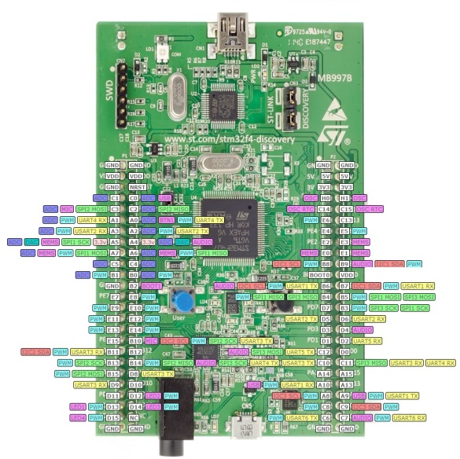
- Go to: Computer Properties Device Manager
- Find “STM32 STLink” and right click Update Driver Software Search automatically for updated driver software

Download and instalation
First download the software from: https://www.keil.com/demo/eval/arm.htm
You may also need to install the Keil Legacy support for Cortex-M devices from: http://www2.keil.com/mdk5/legacy/
You may only have access to the evaluation version that limits code size to 32 Kbytes, but it is sufficient for this course.

INSTALATION
Install the downloaded software.
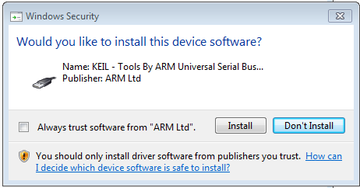
Be aware that during the installation you may be asked if you also want to install the Serial Bus Controller. It is important to install all the drivers in order to ensure the correct communication between the PC and the microcontroller device via USB connection.
Figure 1 Install the bus driver

Once finished, run the program and the Pack Installer (a new component introduced by the latest version) will start. The Pack Installer is a utility for installing, updating and removing board-specific Software Packs. If it does not open automatically select in the top menu: Project – Manage – Pack Installer
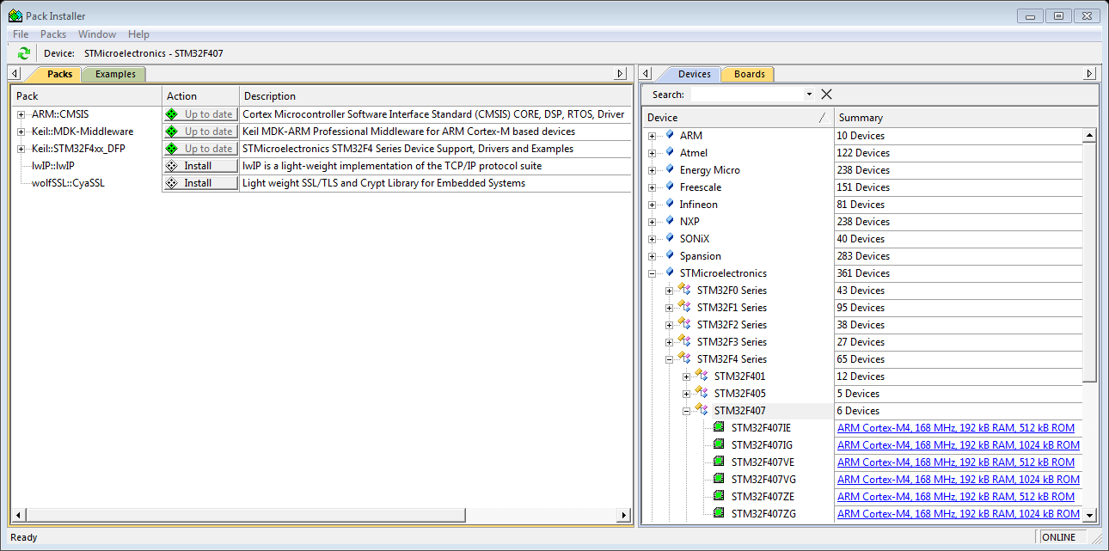
Figure 2 Pack Installer
On the right hand side of the Pack Installer you can search for the STM32F407 family, and on the left hand side the program shows the available documents related with this family. You may download extra libraries but they are not required for this course.
Finally, to be able to connect the device to the computer, you need to install an extra driver provided by STMicroelectronics, which allows the correct recognition of the device.
Alternatively, you can download the ST-Link USB driver from the ST Webpage in the following link: http://www.st.com/web/en/catalog/tools/FM147/SC1887/PF260218?s_searchtype=keyword#

Now, you can connect the STM32F4 board to your computer using a USB type A to Mini-B cable and the device will be recognized with the name STM32 STLink.

Create a new project
To create a new project, open KEIL µVision and select from the top menu project – New µVision project and choose the name and location of the new project. Then you have to select your device from a list. Note that if you haven’t installed the package of your device with the Pack Installer, your device may not appear in the list. The device we are using is STM32F407VG.
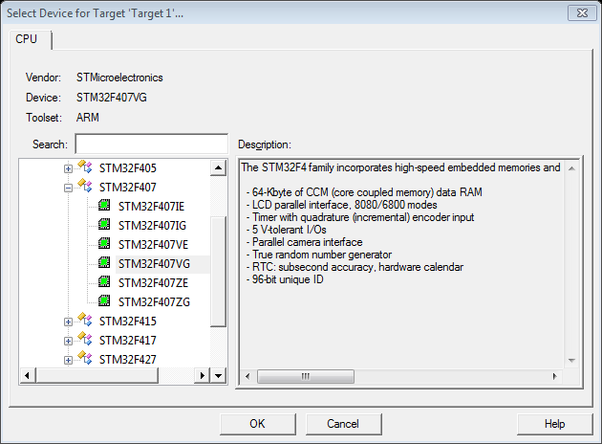
Figure 3 Select STM32F407VG
Then you may need to configure the runtime environment as follows:
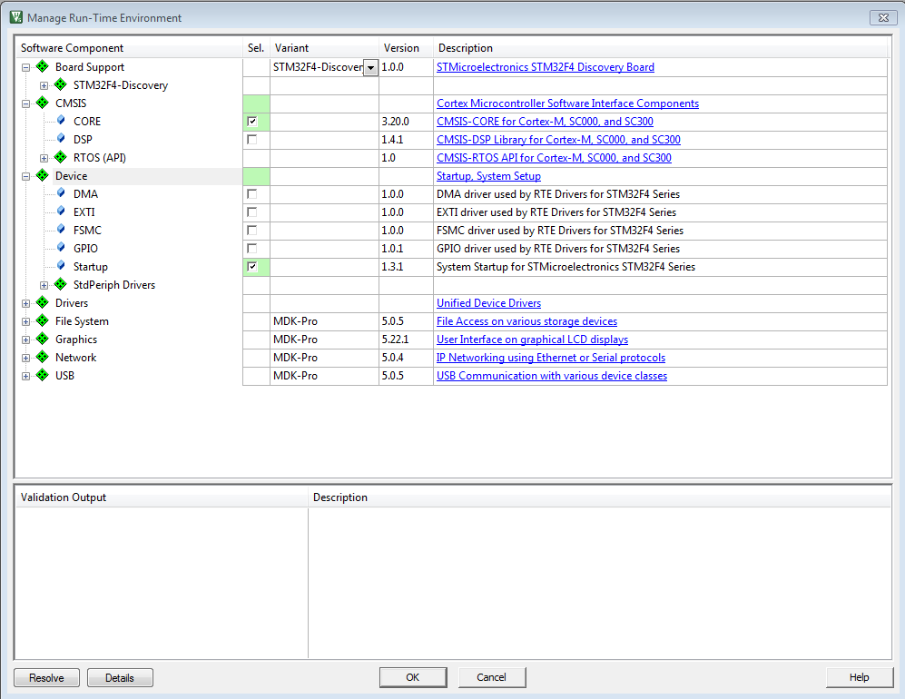
Figure 4 Run-time environment configuration

Then your project file will automatically include the start-up files for the board. You may also include more libraries and other files through the Manage Run-Time Environment icon.
For some compatibility reasons, in some projects, you may need to manually include some of the start-up files instead of using the runtime management.
Then click on the Options for Target icon and do the following:
You need to indicate to the program you are using the ST-Link to communicate with the board. In the Debug tab, select ST-Link Debugger from the list (if you are using the on-board ST-Link Debugger).
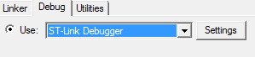
Figure 5: Debugger configuration

Then press setup and select Port SW in the Debug Adapter area. Finally, in Utilities tab, click the Settings button for Use Debug Driver and you need to add the STM32F4xx Flash (On_chip Flash) to the programming algorithm.
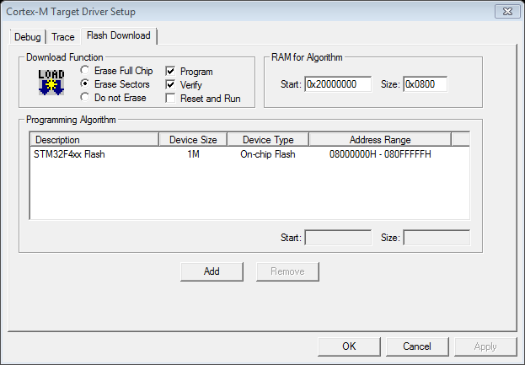
Figure 6: Debugger configuration
Then you may begin adding program files to the project. You can save a template project so that you do not have to repeat all these next time.
You also need a main.c file as the program entry function. Please include the STM32F4xx.header by adding #include "STM32F4xx.h" to your main.c file
You can also use the template project provided.

For further information visit http://www.keil.com/support/

