Intro to System-on-Chip Design Course
LAB 7
Timer, GPIO and 7-Segment Peripherals
Issue 1.0

Contents
1 Introduction 1
1.1 Lab overview 1
1.1.1 Hardware design and implementation: 1
1.1.2 Software programming: 1
1.1.3 Demonstrate the SoC: 1
2 Learning Objectives 1
3 Requirements 2
4 Project files 2
5 Hardware 3
5.1 Overview of the SoC hardware 3
5.2 Timer Peripheral 3
5.2.1 Timer Peripheral Block diagram 3
5.3 GPIO Peripheral 4
5.3.1 GPIO Peripheral Block diagram 4
5.4 7-Segment Display Peripheral 4
5.4.1 Peripheral Block diagram 4
5.5 Memory map 4
6 Software 5
6.1 Software tasks 5
7 Hardware Debugging 6
7.1 On-chip debugging 6
8 Extension Work 7
8.1 Extra task for this lab: 7

Introduction

Lab overview
In this lab, we implement three AHB peripherals: an internal timer, a general-purpose input output (GPIO), and a 7-segment display. The steps to do this include:

Hardware design and implementation:
The processor, bus interface, on-chip memory and peripheral hardware are written in Verilog and provided for you, with some modification/additions needed to make it work. The SoC will be implemented in an FPGA.

Software programming:
The program targeted at the Cortex-M0 processor is written in assembly language and will be used to access the three peripherals. The program is provided for you. You will need to compile it in Keil to generate a code.hex file which will be copied to the FPGA project directory.

Demonstrate the SoC:
- Display the timer on the 7-segment display.
- Use GPIO to interface with the switches and LEDs.
- Analyze the behavior of the peripheral using an on-chip hardware debugging tool.

Learning Objectives
- Implement a simple SoC which consist of Cortex-M0 processor, AHB-Lite bus and AHB peripherals (Program memory and LED, VGA, UART, Timers, GPIOs and 7-Segment) on an FPGA.
- Modify and compile a simple assembly code to initialize the timer.
- Modify and compile a simple assembly code to initialize and start the timer.
- Modify and compile a simple assembly code to display the timer value on the 7-segment display

Requirements
This lab requires the following hardware and software:
- Hardware:
  - Diligent BASYS 3 FPGA board connected to computer via MicroUSB cable. A constraints file for this board is also provided.
  - VGA-compliant monitor and VGA cable to connect your board
- Software
  - Xilinx Vivado
  - Keil uVision
  - TeraTerm

Project files
You will need the files from the previous lab (other than AHBLITE_SYS.v) along with the following files which are provided with this Lab:
File name | Description
AHBTIMER.v | The AHB timer peripheral, including the AHB bus interface
prescaler.v | The prescaler is used to scale-down the frequency for the timer.
AHBGPIO.v | The AHB GPIO peripheral, including the AHB bus interface
AHB7SEGDEC.v | The AHB 7-segment display peripheral, including the AHB bus interface

Hardware
  - Overview of the SoC hardware
The hardware components of the SoC include:
- An Arm Cortex-M0 microprocessor
- An AHB-Lite system bus
- Six AHB peripherals
  - A BRAM memory module
  - A VGA peripheral
  - A UART peripheral
  - An internal timer peripheral
  - A GPIO peripheral
  - A 7-segment display peripheral
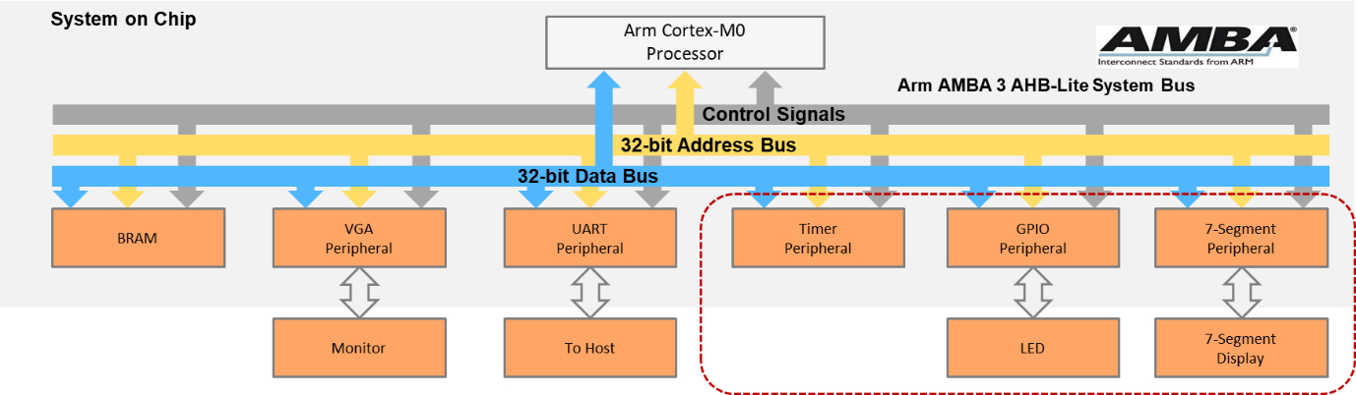
SoC Peripherals

Timer Peripheral

Timer Peripheral Block diagram
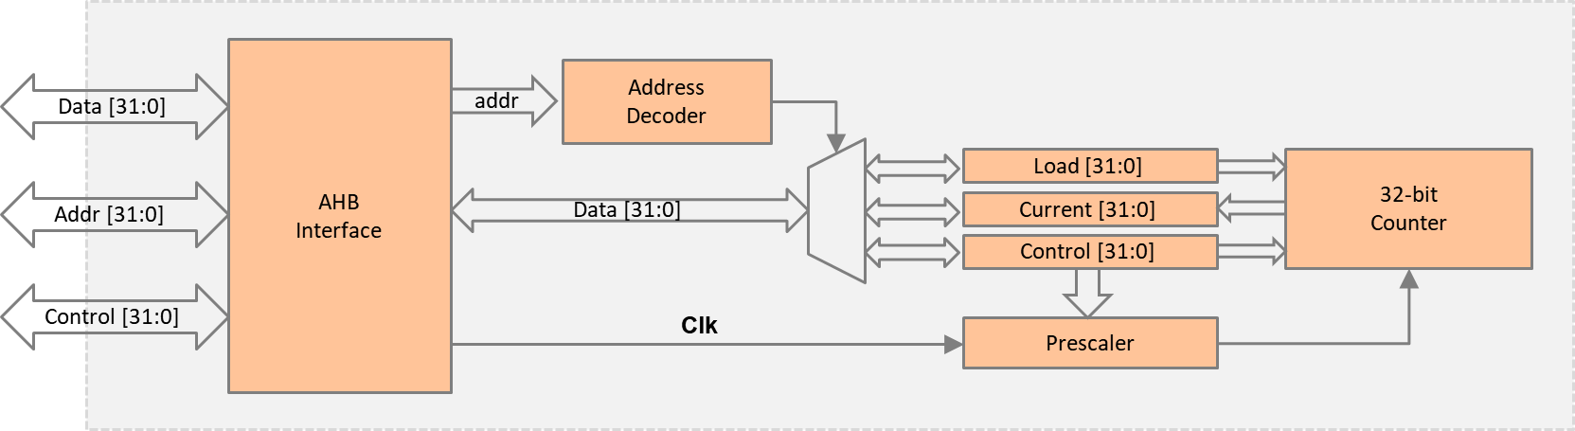
Figure 1:Timer Peripheral Block Diagram

GPIO Peripheral

GPIO Peripheral Block diagram
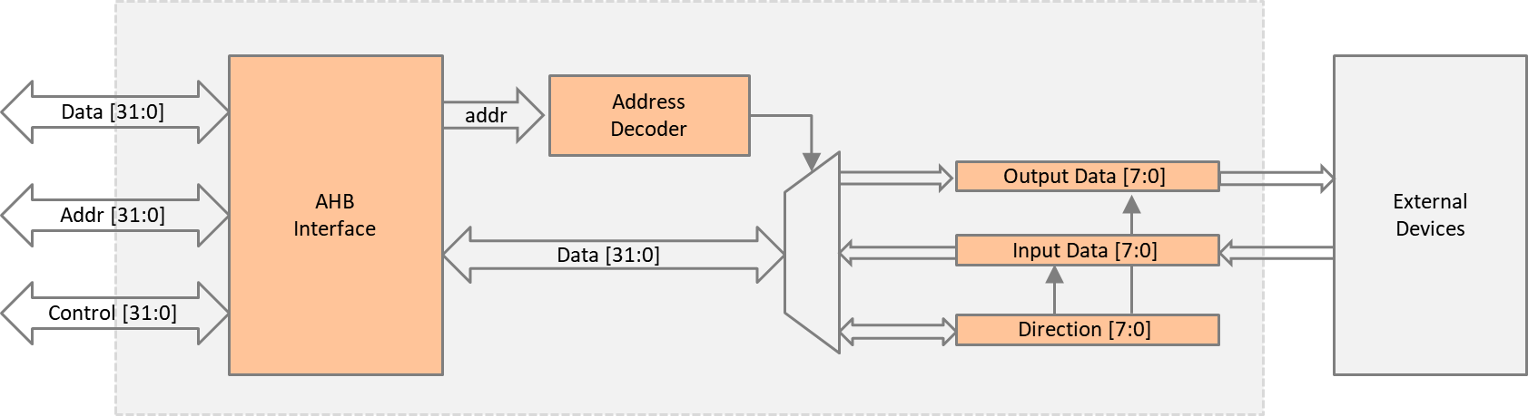
Figure 2:GPIO Peripheral Block Diagram

7-Segment Display Peripheral

Peripheral Block diagram
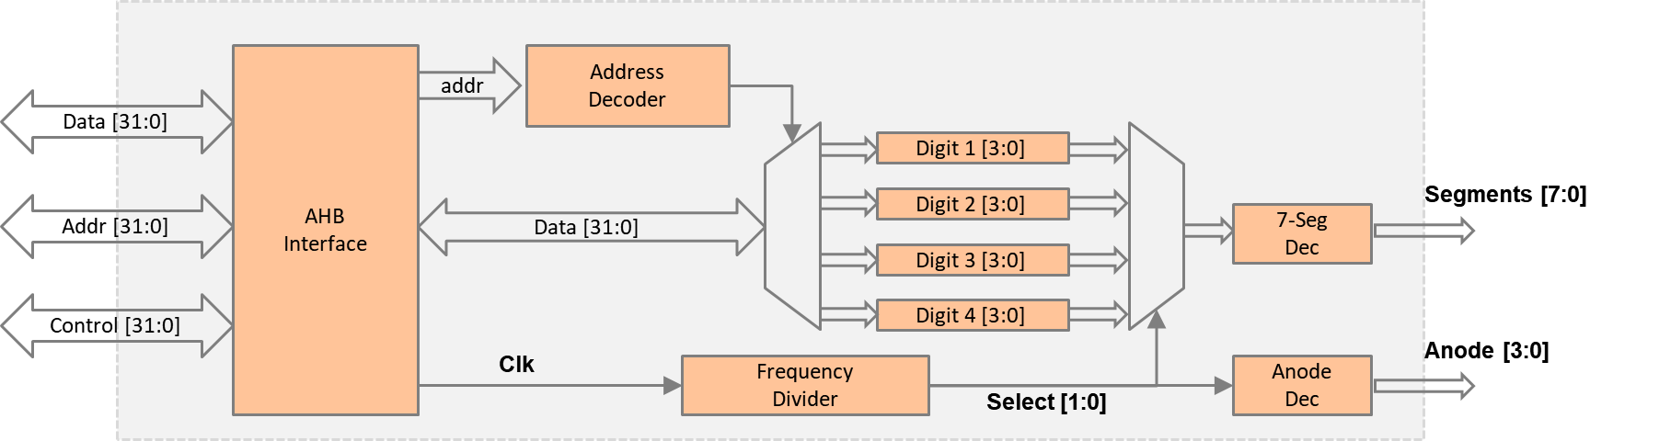
Figure 3:7-Segment Display Peripheral Block Diagram

Memory map
The default memory map of the peripherals is listed below:
MEMORY MAP OF PERIPHERALS
Peripheral | Base address | End address | Size
SRAM | 0x0000_0000 | 0x00FF_FFFF | 16MB
VGA | 0x5000_0000 | 0x50FF_FFFF | 16MB
UART | 0x5100_0000 | 0x51FF_FFFF | 16MB
Timer | 0x5200_0000 | 0x52FF_FFFF | 16MB
GPIO | 0x5300_0000 | 0x53FF_FFFF | 16MB
7-segment display | 0x5400_0000 | 0x54FF_FFFF | 16MB

TIMER PERIPHERAL REGISTERS
Register | Base address | Size
Load value | 0x5200_0000 | 4 bytes
Current value | 0x5200_0004 | 4 bytes
Control value | 0x5200_0008 | 4 bytes
- Load value register: The reset value when the timer reaches zero
- Current value register: The current value of the 32-bit counter
- Control register: Used to start/stop a counter and set the prescaler
GPIO PERIPHERAL REGISTERS
Register | Base address | Size
Data | 0x5300_0000 | 4 bytes
Direction | 0x5300_0004 | 4 bytes
- Data registers
  - Input data: the data read from external devices
  - Output data: the data sent to external devices
- Direction register
  - Controls whether it is a read or write operation
7-SEGMENT DISPLAY PERIPHERAL REGISTERS
Register | Base address | Size
Digit1 | 0x5400_0000 | 4 bytes
Digit2 | 0x5400_0004 | 4 bytes
Digit3 | 0x5400_0008 | 4 bytes
Digit4 | 0x5400_000C | 4 bytes
- Digit 1: the first digit on the 7-segment display
- Digit 2: the second digit on the 7-segment display
- Digit 3: the third digit on the 7-segment display
- Digit 4: the fourth digit on the 7-segment display

Software

Software tasks
Create a new Keil project, add the provided assembly file. This time you will need to edit this file to do the following. When done build the program and copy the code.hex file for the Vivado project.
The main code should be written in assembly and should perform the following:
- Initialize the interrupt vector.
- Display a string (e.g., “TEST”) at the console region (same as previous lab).
- Initialize the timer.
  - Write the load value register.
  - Set prescaler, e.g., 1x or 16x.
  - Change the operation mode.
    - Free-run mode: the timer resets on overflow.
    - Load mode: the timer resets when reaching the value in the load register.
  - Start the timer
Then repeat the following:
- Display the timer
  - Read the current timer value.
  - Choose the higher bytes, e.g., 16-bit MSB.
  - Display the value on the 7-segment display using the four digits.
- GPIO test
  - Change the direction of the GPIO to read mode.
  - Read the switch value from the GPIO.
  - Change the direction of the GPIO to write mode.
  - Write the switch value to the LEDs.

Hardware Debugging

On-chip debugging
Use an on-chip debugging tool to sample and analyze the signals at run-time. Suggested signals are as follows:
Towards AHB bus:
- HADDR[31:0]
- HWDATA[31:0]
- HRDATA[31:0]
- HWRITE
- HREADY
- HSIZE[2:0]
- HTRANS[1:0]
- HRESP
Towards the peripherals:
- Timer_Select
- Timer_Write
- Timer_Ready
- Timer_Data
- GPIO_Select
- GPIO _Write
- GPIO _Ready
- GPIO _Data
- 7-SEG_Select
- 7-SEG _Write
- 7-SEG _Ready
- 7-SEG _Data

Extension Work

Extra task for this lab:
- In the timer peripheral, add more operation modes to the timer, such as compare mode, capture mode, or PWM mode.
- In the GPIO peripheral, add a mask register that can mask out certain bits while writing to the GPIO.
- In the 7-segment display peripheral, add a register to change the display mode, such as display in hex or decimal.

