Intro to System-on-Chip Design Course
LAB 9
Programming an SoC using C Language
Issue 1.0

Contents
1 Introduction 1
1.1 Lab overview 1
1.1.1 Software programming: 1
1.1.2 Demonstrate the SoC: 1
2 Learning Objectives 1
3 Requirements 2
4 Provided files 2
5 Software 3
5.1 Program procedure 3
5.2 An example of the demo: 4
6 Extension work 4
6.1 Extra tasks for this lab: 4

Introduction

Lab overview
In the previous labs, assembly language was used to program the SoC at low-level, which gave better control over the hardware and helped us understand the hardware mechanism at register transfer level (RTL).
In this lab, C language will be used to program the SoC at a higher level, whereby compilers, software libraries, and tools can be used to hide the complexity of low-level management. This means that we can make more complicated applications in a more efficient way.
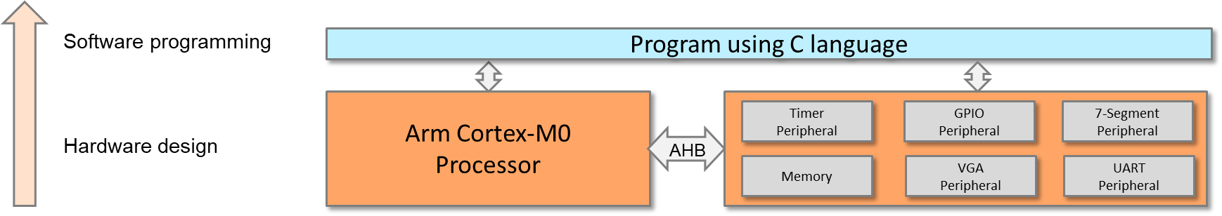

One can always mix C and assembly code in one project, or even in one file.
Hardware implementation has been completed in the previous labs; the following labs will focus on software. The work in this lab includes:

Software programming:
- Program the Cortex-M0 processor and control the peripherals using C language.

Demonstrate the SoC:
- Use the timer interrupt to implement a counting up counter (counting from 0 to 9) and display the value to the VGA display (same as previous lab but using C programming).
- Use the UART interrupt to send characters to a PC or laptop (same as previous lab but using C programming).
- Input from 8-bit switch and output to LEDs

Learning Objectives
- Implement a timer interrupt handler and UART interrupt handler in a high-level language such as C.
- Modify a C program to enable the timer and UART interrupts.
- Modify a C program to set the interrupt priority of the timer and UART interrupts.
- Modify a C program to initialise the timer to generate an interrupt at regular interval.

Requirements
This lab requires the following hardware and software:
- Hardware:
  - Diligent BASYS 3 FPGA board connected to computer via MicroUSB cable. A constraints file for this board is also provided.
  - VGA-compliant monitor and VGA cable to connect your board
- Software
  - Xilinx Vivado
  - Keil uVision
  - TeraTerm

Provided files
You will need the files from the previous labs along with the following files which are provided with this Lab:

File name | Description
cm0dsasm.s | The assembly file that includes interrupt vectors and part of the interrupt service routines
main.c | The C code that contains the main program and part of the interrupt service routines

Software

Program procedure
The assembly code in cm0dsasm.s should perform the following:
- Initialize the interrupt vector.
- Define heap and stacks.
- Reset handler.
  - Branch to the main code in main.c.
- Timer handler
  - Push registers (e.g., R1 – R4) to the stack.
  - Branch to the timer interrupt service routine in main.c.
  - Pop registers from the stack.
- UART handler
  - Push registers (e.g., R1 – R4) to the stack.
  - Branch to the UART interrupt service routine in main.c.
  - Pop registers from the stack.
The C code in main.c should perform the following:
- Main program
  - Set the timer interrupt priority to 0x00 (higher).
  - Set the UART interrupt priority to 0x40 (lower).
  - Enable interrupts for the timer and UART.
  - Reset the 7-segment display.
  - Initialize the timer to generate an interrupt every second.
    - Write the load value register, e.g., 50,000,000.
    - Set prescaler, e.g., 1x or 16x.
    - Change the operation mode to load mode.
  - Start the timer.
  - Repeat the following:
    - Change the GPIO to read mode.
    - Read from the switches using the GPIO.
    - Change the GPIO to write mode.
    - Write to the LEDs.
- Timer interrupt handler
  - Clear the timer interrupt request.
  - Increment the counter.
  - Display the counter to the VGA text region.
  - Disable the timer interrupt if the counter reaches 9.
- UART interrupt handler
  - Read from the UART (from the keyboard).
  - Write to the UART (to the terminal window).

An example of the demo:
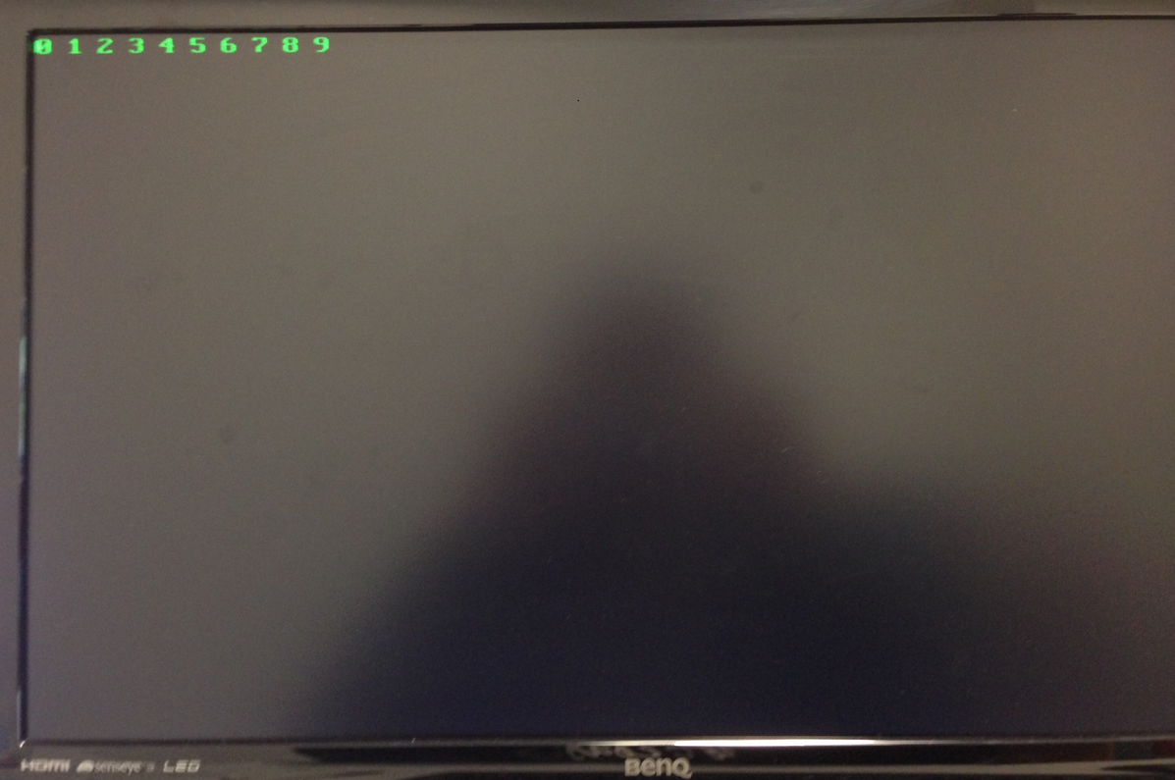
Figure 1:VGA Demo

Extension work

Extra tasks for this lab:
- Optimize the code in both operational speed and code density. You can use:
  - Embedded assembly code in C code
  - Embedded C code in assembly code
- Evaluate the coding efficiency between handwritten assembly code and assembly generated by the compiler.

