Intro to SoC Design Course
LAB 11
API and Final Application
Issue 1.0

Contents
1 Introduction 1
1.1 Lab overview 1
1.1.1 Software programming: 1
1.1.2 Demonstrate the SoC: 1
2 Learning Objectives 1
3 Requirements 2
4 Provided files 2
5 Software 3
5.1 API Development 3
5.1.1 Create API file 3
5.1.2 Add the retarget file 3
5.1.3 File structure 4
5.2 Application development 5
5.2.1 Application using polling 5
5.2.2 Application using interrupt (power saving) 5
5.2.3 Example of the demo: 6
6 Extension work 6
6.1 Extra tasks for this lab: 6

Introduction

Lab overview
In previous labs, we used the CMSIS and developed drivers for the peripherals. In this lab, we will develop an API that has more generic and easy-to-use functions. Then, based on the API, we will develop a final game application: Snake.
The work in this lab includes:

Software programming:
- Using the functions provided by software drivers and CMSIS, develop an API that provides more generic and easy-to-use functions for application development.

Demonstrate the SoC:
- Develop a final application (such as the Snake game) to demonstrate the SoC
- Use sleep mode to reduce the power consumption of your application

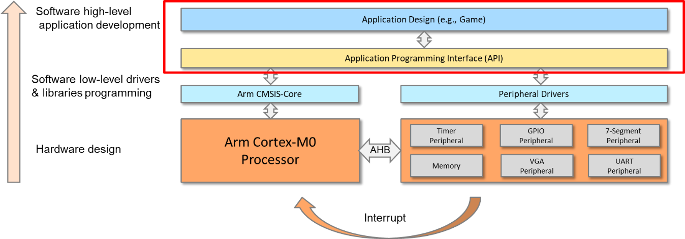
Figure 1: API and Application Development hierarchy

Learning Objectives
- Modify reusable and easy to use APIs.
- Develop a single player snake game using C program which implements UART and timer interrupt handlers to control and display/ detect the snake’s coordinates.

Requirements
This lab requires the following hardware and software:
- Hardware:
  - Diligent BASYS 3 FPGA board connected to computer via MicroUSB cable. A constraints file for this board is also provided.
  - VGA-compliant monitor and VGA cable to connect your board
- Software
  - Xilinx Vivado
  - Keil uVision
  - TeraTerm

Provided files
You will need the files from the previous labs along with the following files which are provided with this Lab:
File name | Description
core_cm0.h | CMSIS Cortex-M0 core peripheral access layer header file
core_cmFunc.h | CMSIS Cortex-M core function access header file
core_cmInstr.h | CMSIS Cortex-M core instruction access header file
cm0dsasm.s | Includes interrupt vectors and other setup assembly code
main.c | Includes the main program and interrupt service routines
EDK_CM0 | Defines the interrupt numbers and memory map etc.

Software

API Development

Create API file
Under the “Device” folder, create a head file called “API.h” and a C file called “API.c”.
Write the functions in “API.c” and include all the function calls in “API.h”.
Suggested functions are as follows:
API Functions | Description
void SoC_init(void) | SoC initialization
void rectangle(int x1,int y1,int x2,int y2, int color) | Draw a rectangle on the screen.
void clear_screen (void) | Clean up the screen.
int read_switch | Read the value of the 8-bit switches.
write_LED | Write a value to the 8-bit LEDs.
void Display_Int_Times (void) | Display the number of interrupts that occurred using the 7-segment display.
void delay(int value) | Software delay program
char random (char min, char max) | A simple random generator based on system tick

Add the retarget file
The retarget file allows us to use print library functions such as “printf()”. To add the retarget file:
- Add the “retarget.c” file to the “Device” folder.
- Implement the retarget functions, for example:
Retarget Functions | Description
int KBHIT(void) | Wait for keyboard hit.
int fputc(int ch, FILE *f) | Input characters
int fgetc(FILE *f) | Output characters
unsigned char VGAPutc(unsigned char my_ch) | Output characters to VGA
unsigned char UartPutc(unsigned char my_ch) | Output characters to UART
unsigned char UartGetc(void) | Input characters from UART

Example code:
//define UartPutc
unsigned char UartPutc(unsigned char my_ch)
{
UART->DATA=my_ch;
return (my_ch);
}
//define fputc
int fputc(int ch, FILE *f) {
return (UARTPutc(ch));
}
//use printf in main.c
printf("HelloWorld");

File structure
The files can be organized as follows:
Core folder
Device folder
Application folder
core_cm0.h
cm0dsasm.s
main.c
core_cmFunc.h
core_cmInstr.h
EDK_CM0.h
edk_driver.c
edk_driver.h
edk_api.c
edk_api.h
retarget.c

Application development
The following ideas can be used to program the Snake game:

Application using polling
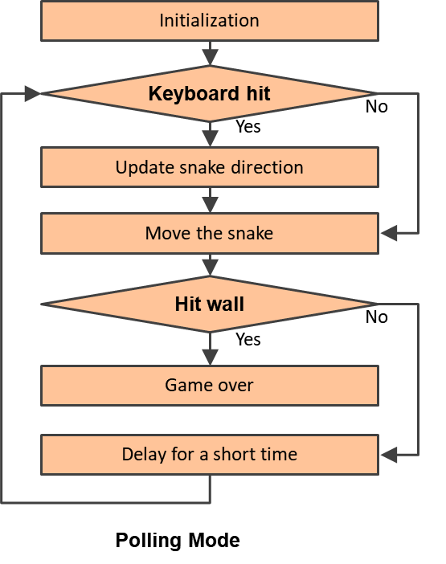
- Main program
  - Initialize the SoC.
  - Initialize the game.
  - Repeat the following:
    - Check if keyboard hits; if yes, then,
      - Update snake direction.
    - Move the snake.
    - Check if it hits the wall; if yes, then,
      - Game over
    - Delay for a short time.

Application using interrupt (power saving)
- Main program
  - Initialize the SoC.
  - Initialize the game.
  - Enter the sleep-on-exit mode.
- Timer interrupt handler
  - Trigger the snake to move one step.
  - Detect if the target is reached or if the snake hits the wall.
- UART interrupt handler
  - Input the command from the keyboard.
  - Change the direction of the snake.
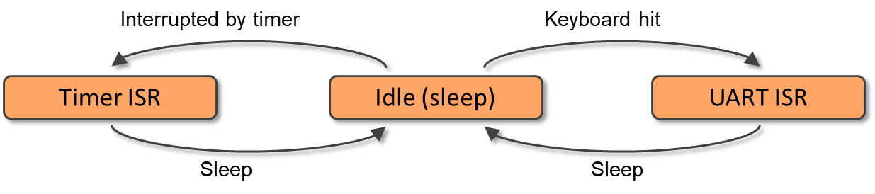
Interrupt-driven Mode

Example of the demo:
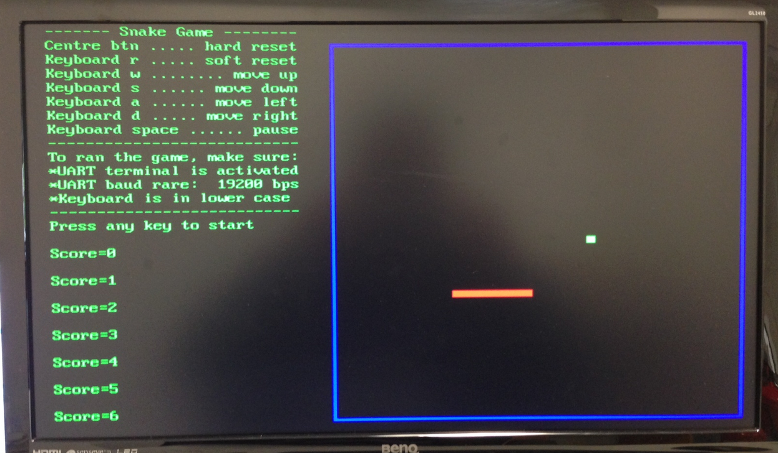
Demo Example

Extension work

Extra tasks for this lab:
- Use a sampling energy meter (or other equipment) to measure the run-time power consumption of your game application.
- Optimize your code to reduce power consumption.
- Explore other games, such as TERIS, PACMAN, BREAK, TICTAC, etc.

