Introduction to Graphics and Mobile Gaming
Unity LAB 1
Installing Unity
Issue 1.0

Contents
1 Introduction 1
2 System requirements 1
3 Installation guide 1
4 Unity example project 2
5 Install the apk 3

Introduction
This lab will explain how to install all of the components that are required to develop with the Unity engine.
At the end of the installation process, you will also play around with a simple demo that has been made for you and test it on the android device.

System requirements
Please note that this process may take over an hour, depending on your internet speed.
- Unity will require about 8GB of disk space.
- Java will require 180MB of disk space.
- Android will require 203MB of disk space.

Installation guide
To install Unity Personal Edition, follow this link: https://store.unity.com/download?ref=personal and download ‘Unity Hub’, and then run the executable. At the end of installation, the Hub will open, and you will notice that there is yet “No Unity version” installed. Click on the Add button and select the latest Unity version to be installed, we recommend to use Unity 2019.3.2f1 or 2020.1.0a24. Next, please ensure that you enable Android Build Support, along with Android SDK&NDK Tools and OpendJDK to be included;
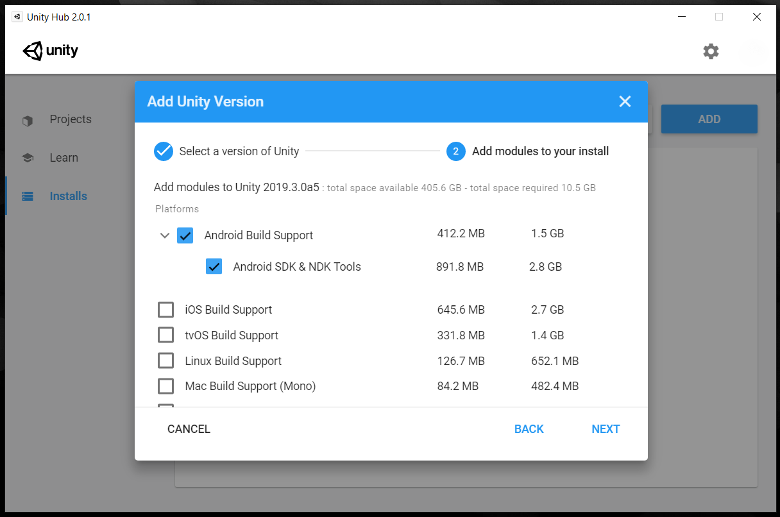

Unity example project
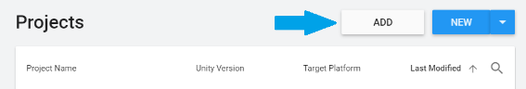
Now we want to import our example project into Unity. Navigate to the LabResources zip folder and extract the folder inside called ‘ExampleProject’.
Open the Unity Hub, and in the Projects tab, click on Add.
Navigate to the location of your ExampleProject. If your Unity version and the build Unity version do not match, just update the project to your current version (this might take a while).
If your unity hub does not select a unity version automatically for the project, select the newest one
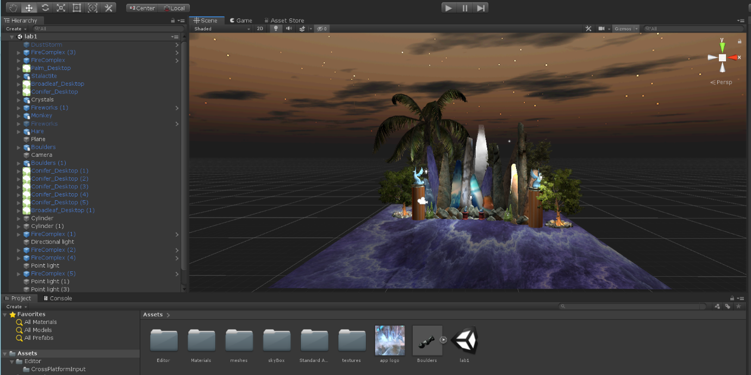
You should be able to see the scene below. Note: You may need to look around with the camera to view the scene.
Let’s explore Unity in preparation for the next lab where we will introduce the main basic commands and functions.
If you click on the camera in the middle of your scene, you can see a preview of it (if you can’t find the camera in the scene, click it from the Hierarchy panel on the left). This will show you what objects are in the view frustum. Try exploring the assets and add a couple of objects in the scene. You can scale objects to make them larger or smaller, change the orientation, rotation, and many other functions. You also have a number of meshes and materials available. For a better understanding of the Unity commands, please refer to the official documentation at: https://docs.unity3d.com/Manual/UsingTheSceneView.html
Once you have created your scene, run a simulation of the scene by pressing the play button. This will also activate the animations and moving objects.

Install the apk
Simply connect your android device to your PC. You will be prompted to give permission for the connection. Make sure your device has USB debugging enabled before doing this step. You might have already done this for the previous Android Studio labs.
Click on File-> Build settings (or Ctrl+Shift+B) and then select “Android” and click on Player Settings at the bottom.
The settings will appear in the Inspector tab on the right side of the screen; we need to enter the following details:
• First, add a company name and a product name
• Under the “Resolution and Presentation” tab, untick the following options: “Portrait”, “Portrait Upside Down” and “Landscape Right”; we only want “Landscape left” checked.
• Then, click on “Other Settings” and change the Bundle Identifier to com.YourCompanyName.UnityLab;
Close the Player Settings.
You will notice that the Build and Run button is gray and cannot be clicked. That is because we need to re-build the project for Android devices. Please click Switch Platform and wait for the magic to happen (this will take a while). When that’s finished, click Build and Run, and if everything goes smoothly, the app should pop up on your device.
Whenever changes are made to the scene or the project, these will only be updated in the .apk file if it is rebuilt.

